


State of Scotland’s Water Environment
July 2024

Summary Report
2023

If you would like this document in an accessible format, such as large print, audio recording or braille, please contact SEPA by emailing equalities@sepa.org.uk

State of Scotland’s Water Environment Summary Report 2023

Introduction
SEPA has a key role in protecting and improving the status of the water environment in Scotland during a time when climate change, urbanisation and intensification of land use are all increasing. Consequently, preventing deterioration in the condition of our groundwater, rivers, lochs, transitional waters (eg estuaries) and coastal waters is a major focus of SEPA’s work. Improvements are driven by investment, required by SEPA from businesses to reduce their environmental impacts. This report explains how the status of our water environment has changed between 2022 and 2023 and places this change in the context of classification results since 2008.

Classifying Scotland’s Water Environment
Classification is how we define the state of Scotland’s water environment and is based on EU and Scottish guidance. Annual classification is produced for all water bodies in Scotland, underpinned by environmental monitoring and modelling designed to assess long-term changes and driven by risk assessments based on pressure information and areas of known risk. All water features above a certain size threshold are split into management units called water bodies. Water bodies are placed into the following categories: rivers, lochs, estuaries (also called transitional waters), coastal waters, and groundwater. Table 1 shows the total number of water bodies classified in Scotland.

The classification provides evidence on where the status of the water environment is good and where it requires improvement. This information is used to understand long term trends showing improvements in overall status, and to inform actions undertaken in River Basin Management Planning.

Table 1: Number of water bodies classified in Scotland
Rivers | Lochs | Estuaries | Coastal | Ground Water | Total
2410 | 334 | 48 | 457 | 403 | 3652

Classification is based on an assessment of biological quality elements (invertebrate animals, aquatic plants and fish), supported by measurements of chemistry (physico-chemical properties, nutrients, pollutants and metals), hydrology (changes to water flows and water levels), morphology (changes to the physical condition of beds, banks and shores of water bodies), and assessment of aquatic invasive non-native species (INNS). A range of these assessments are incorporated into the classification of individual water bodies.

This classification incorporates data collected throughout the year from January to December; the samples are analysed and the results classified and checked. If any single aspect of a water body is classified as below good, that water body’s overall condition is reported as below good. Therefore, overall status can mask considerable improvements for individual elements.

Summary of 2023 Classification Results
Scotland’s water environment classification results have been updated for 2023, incorporating all data available up until 31/12/2023.

Since the previous results for 2022 were produced, the proportion of our water environment assessed as being in good or better overall condition has increased from 67.1% to 67.9%. There are additional improvements to individual aspects of classification themes, such as access for fish migration and water flows and levels (water resources), although these do not necessarily result in improvements to the overall condition due to the presence of other impacts. These additional improvements are explained below. Table 2 shows the proportion of those water bodies currently in good or better condition.

The detailed results for individual parameters will be published on SEPA’s water classification hub.
Table 2: Overall condition of Scotland’s water environment (percentage)
 | Rivers (%) | Lochs (%) | Estuaries (%) | Coastal (%) | Groundwater (%) | Total
High/good | 58.2 | 69.8 | 87.5 | 99.6 | 85.9 | 67.9
Below good | 41.8 | 30.2 | 12.5 | 0.4 | 14.1 | 32.1

It is important to note that as well as our classification monitoring programme we continue to monitor the compliance of discharges for regulated sites, undertake a monitoring and classification programme for bathing waters and analyse samples taken in response to significant pollution events.

SEPA uses the monitoring data collected to assess the condition of water bodies using the following themes:
- water quality
- water flows and levels
- physical condition
- fish migration
- freedom from invasive non-native species

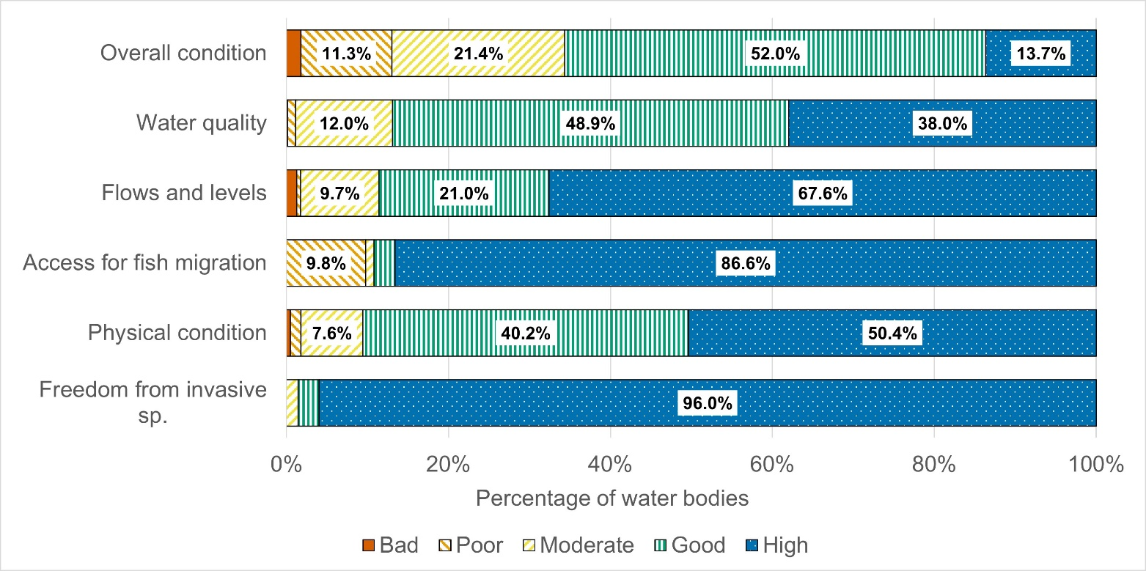Figure 1: Overview of the state of surface water bodies in 2023 classification
Note: See Annex 1 for a table of detailed percentages for all themes in Figure 1. Surface water bodies include rivers, lochs, estuaries and coastal waters. Fish migration and water flows and levels parameters are not relevant to classification of estuaries and coastal waters.

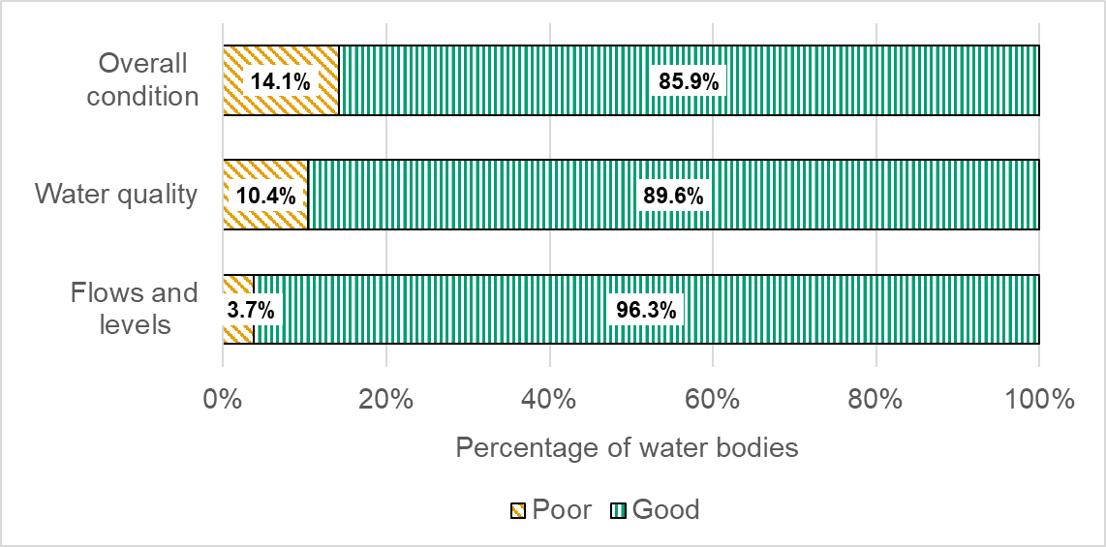Figure 2: Overview of the state of groundwater bodies in 2023 classification
Note: Groundwater bodies are classified as either good or poor status.

What has changed since 2022?

Overall condition
There have been 43 water bodies that have moved to good or better for overall condition that were previously less than good, and 16 water bodies have moved to below good.

Of the 43 changes to good or better for overall condition:
- 12 are the result of improvements in the environment where we are confident these are sustained long-term changes.
- 6 are due to improvements that require further monitoring to confirm if they show a long-term improvement.
- 15 are a result of collecting new data on natural or pre-existing conditions, rather than actual environmental changes.
- 10 are due to an improvement in how we assess the environment.

Of the 16 changes to less than good for overall condition:
- 3 are changes in the environment and these will be addressed through the RBMP process.
- 2 are due to a deterioration that requires further monitoring to assess if it is a long-term trend.
- 10 are due to new data on pre-existing conditions rather than actual environmental changes.
- 1 is due to an improvement in how we assess the environment.

Figure 3 provides an overview of the overall condition and theme level changes we have observed for 2023. Not all theme level changes will contribute to a change in overall condition because this is determined by the worst-case condition of the five themes. The number of water bodies that downgraded in 2023 for overall condition is lower than the number of downgrades seen in the five RBMP themes. This is because some of the water bodies that have downgraded in 2023 for an individual RBMP theme (e.g. flows and levels) would have already had an overall condition of less than good due to another RBMP theme being at less than good in 2022. Therefore, they are not counted in the 2023 overall condition downgrades as there is no new downgrade overall. In all cases where a water body has a new downgrade in overall condition in 2023, this was due to a change in only one of the RBMP themes.

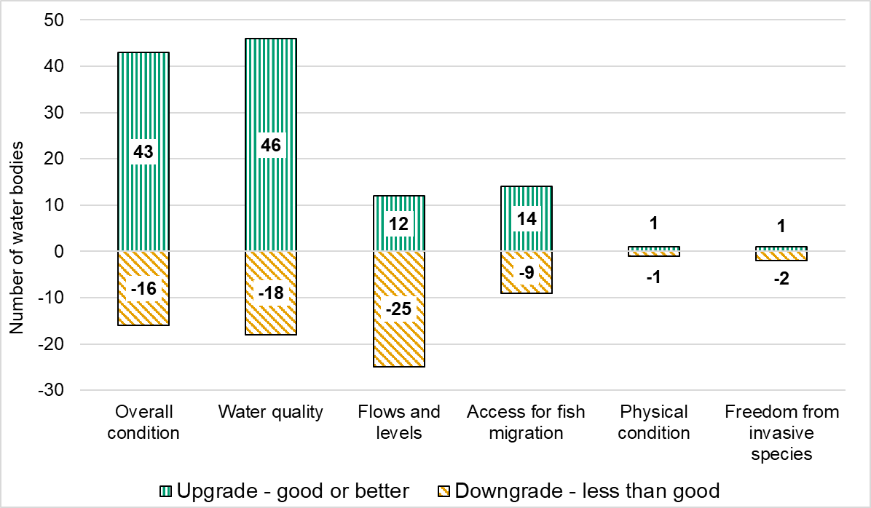Figure 3: Changes since 2022 classification
Note: Figure 3 shows the number of water bodies that have changed classification between good or better and less than good condition for both groundwater and surface water bodies for overall condition and the five themes.

Long term trends
Since the start of water environment classification for River Basin Management Planning in 2008, the overall condition of Scotland’s water bodies has improved each year. The percentage of surface water bodies that were classed as good or better in 2008 was 61% (1972 water bodies out of 3233 water bodies) and is now 65.6% (2132 water bodies out of 3249 water bodies), demonstrating an improvement of 4.6 percentage points since 2008 (Figure 4). Additionally, the number of surface water bodies at bad overall condition has decreased from 224 in 2008 to 57 in 2023, an improvement of 74.6% of these water bodies that indicates an upward trend in overall condition.

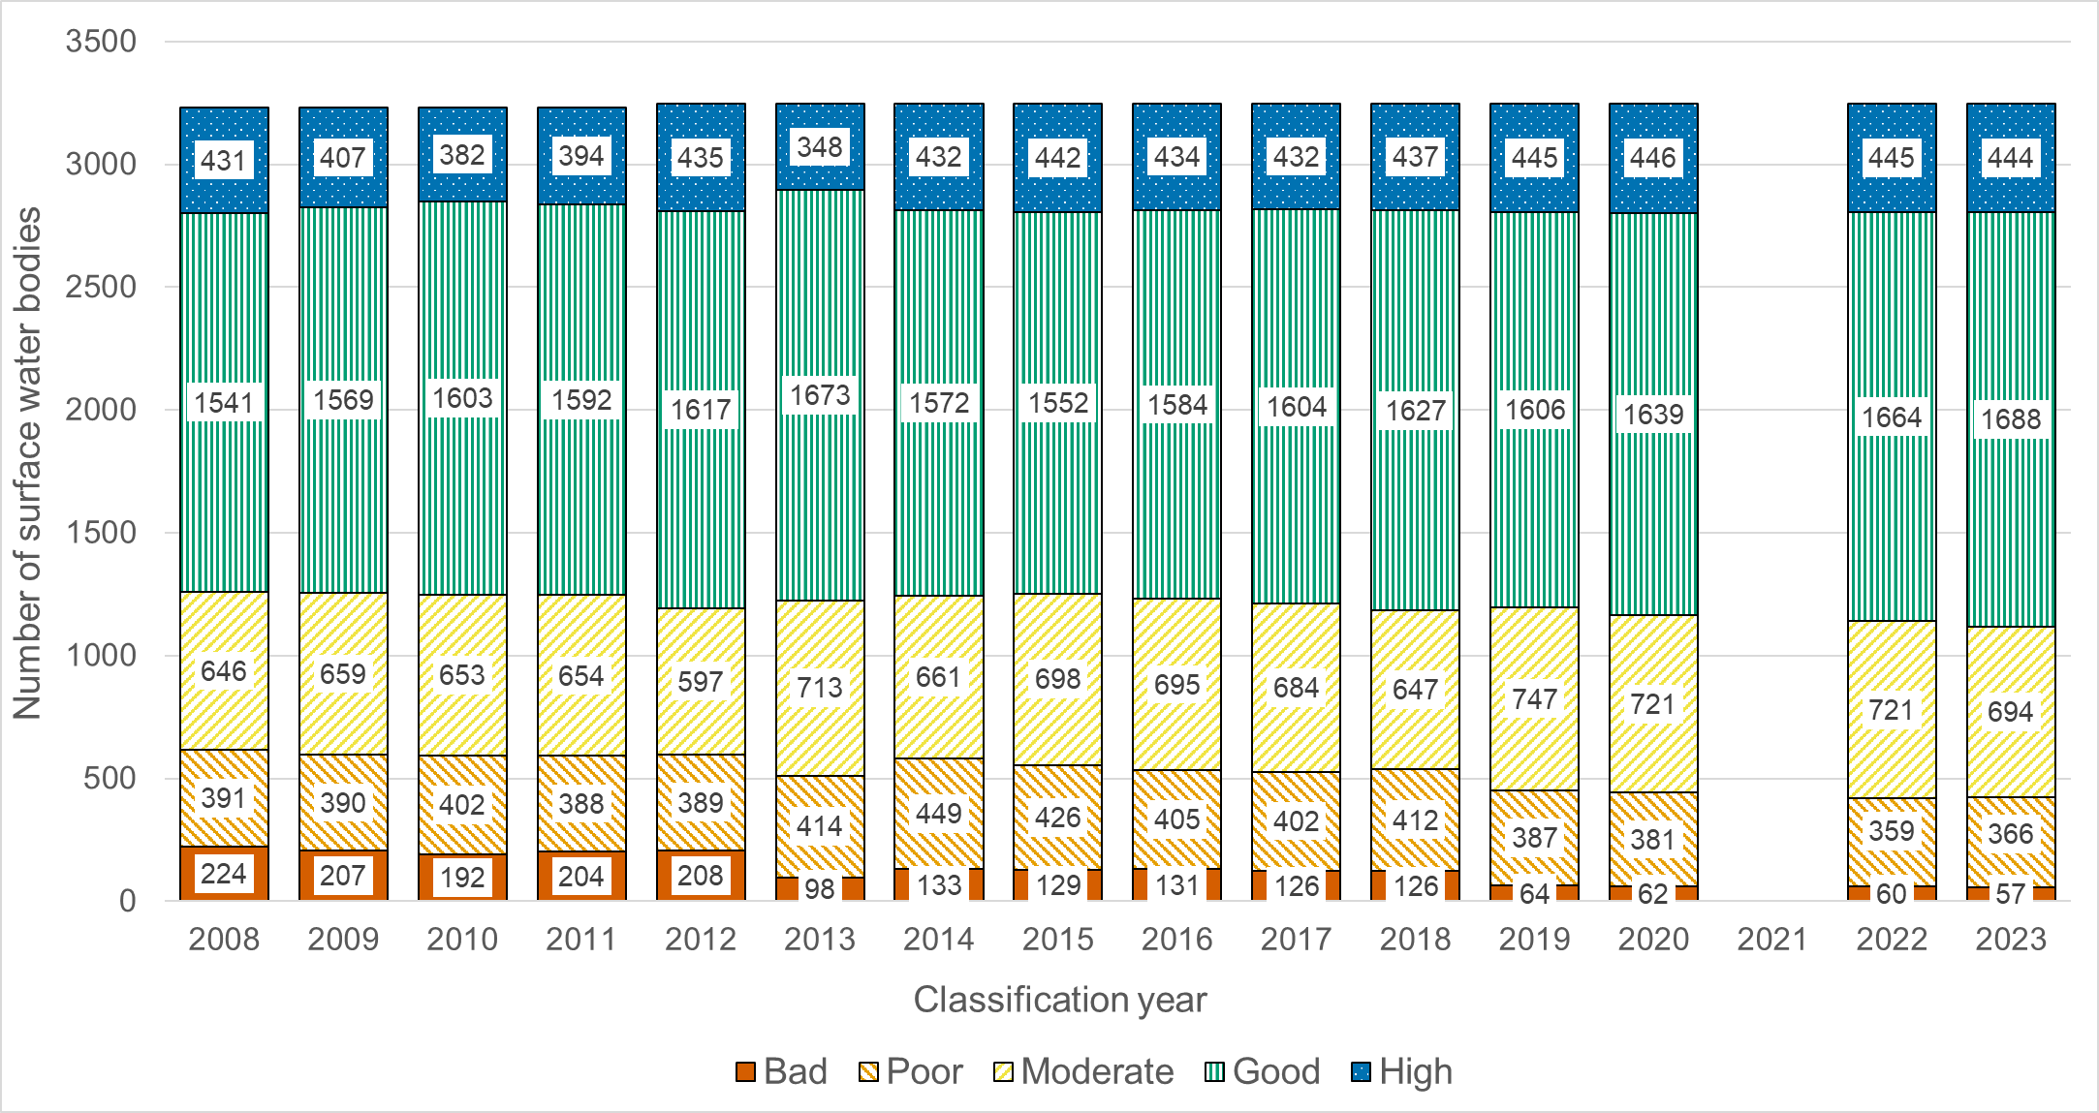Figure 4: Long term trend in the overall condition of surface water bodies

The percentage of groundwater bodies that were classed as good in 2008 was 77.3% and is now 85.9%, demonstrating an improvement of 8.6 percentage points since 2008 (Figure 5).

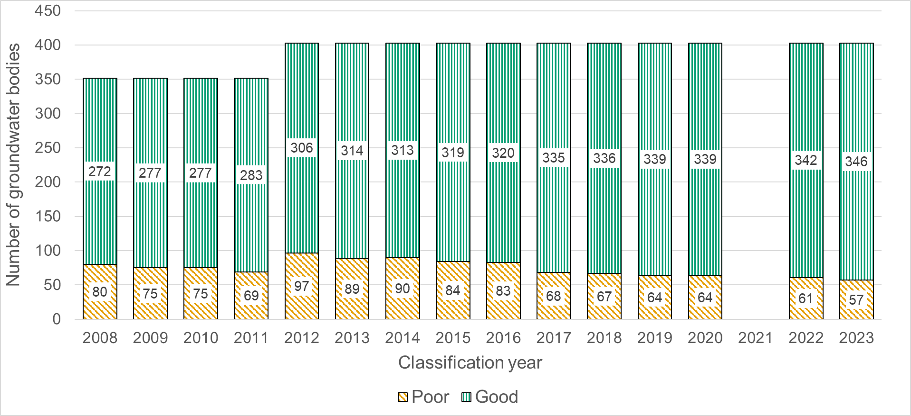
Figure 5: Long term trend in the overall condition of groundwater bodies

Next steps
Reporting on the state of our water environment is a key element of the river basin management process and helps us to evaluate where actions are contributing to improving the environment. In December 2025, the Significant Water Management Issues (SWMI) report will be published, the precursor to the next river basin management plan (RBMP4), setting out the biggest challenges for the future of Scotland’s water environment.

Annex 1
Table 1: Overview of the state of surface water bodies in 2023 classification
Classification theme | High (%) | Good (%) | Moderate (%) | Poor (%) | Bad (%)
Overall condition | 13.7 | 52.0 | 21.4 | 11.3 | 1.8
Water quality | 38.0 | 48.9 | 12.0 | 1.0 | 0.1
Flows and levels | 67.6 | 21.0 | 9.7 | 0.5 | 1.2
Access for fish migration | 86.6 | 2.6 | 1.1 | 9.8 | 0.0
Physical condition | 50.4 | 40.2 | 7.6 | 1.3 | 0.5
Freedom from invasive species | 96.0 | 2.6 | 1.4 | 0.0 | 0.0

Annex 2
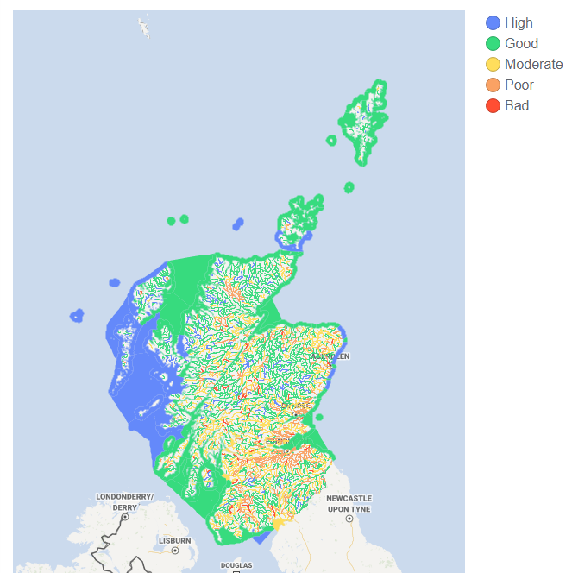
Figure 1. Map of Scotland’s surface water bodies, showing the 2023 overall condition classification status

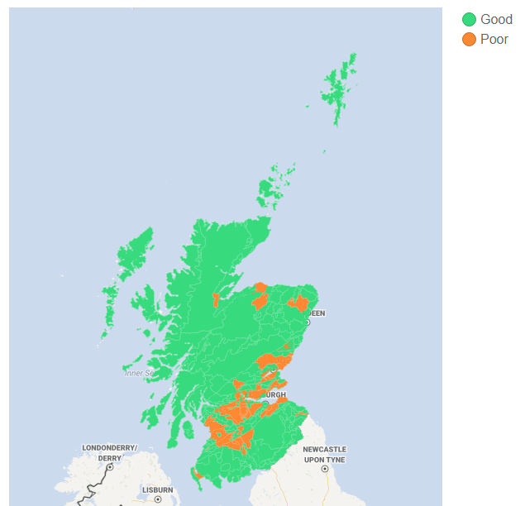
Figure 2. Map of Scotland’s groundwater bodies, showing the 2023 overall condition classification status

Annex 3

Glossary
Fish migration: SEPA evaluates structures such as weirs, culverts and bridges, which can block migratory routes for fish and deny them access to good quality habitat for spawning and rearing.
Freedom from invasive species: An assessment to evaluate the presence or absence of non-native species in the water environment.
Heavily modified water body (HMWB): A surface water body which, as a result of physical modifications by human activity, is substantially changed in character. The physical modifications must be for the purpose of providing specific socio-economic benefits, rather than commercial gain.
Overall condition: SEPA classifies the overall condition of surface water and groundwater bodies by combining data, where appropriate to the water body type, on biological and chemical quality elements, hydrology, morphology, and assessment of aquatic invasive non-native species (INNS). The overall condition is based on the worst condition of any of these elements.
Physical condition: SEPA assesses the physical condition of morphological elements of the water environment to understand the extent and impacts of modifications and structures, such as embankments; culverts; and the widening and straightening of rivers. All these activities can affect the benefits Scotland derives from the water environment, such as reduced flood risks; enhanced landscape quality; improved habitats for animals and plants; and health/wellbeing and recreation for people.
Reasons for classification status changes:
- Change in how we have assessed the environment: SEPA will make adjustments to our methods where necessary to more accurately assess the environment. Changes to methods are thoroughly reviewed to ensure that the most reliable and consistent data are used to inform classification status.
- New data on natural or pre-existing conditions: When SEPA carries out surveys we sometimes identify new natural or pre-existing conditions that were not previously known. This changes our understanding of the impacts and can result in a change in classification status.
Remote sensing: Using data processed from satellite imagery to assess the environment.
Sonde monitoring: A piece of equipment placed in the environment to monitor water quality in situ.
Water body: A defined area of water. Surface water bodies are rivers, lochs, estuary, or coastal areas. Groundwater bodies are sub-surface areas of freshwater.
Water classification hub: An interactive data tool on Scotland’s Environment Web website that allows you to view classification data for the current and previous years.
Water flows and levels: Monitoring water resources (the flows and levels of water) indicates how much water is being used and how much is available to serve all its vital functions. This information is essential for managing water efficiently.
Water quality: SEPA monitors water quality to ensure that potentially harmful substances are within safe levels, and that the loss of valuable resources such as soil and nutrients can be identified and minimised.

