


Radioactive Substances
Application Information Note

Version 15: April 2025 to March 2026

This information note applies to all applications for radioactive substances activities under the Environmental Authorisations (Scotland) Regulations 2018 (EASR18).

Contents
1. What type of application do I need? 2
1a. Changing authorisation tier 2
1b. Nuclear variation applications 2
2. Who can make application? 2
3. Who will you consult with on my application? 3
4. What are Standard Conditions? 3
5. Why do we ask about a Justified Practice? 3
6. Where can I find the application fee? 3
7. How do I submit the form? 4
8. What happens when we get your application? 4
9. Disclosure of information you give us in your application. 5
10. What about commercial confidentiality and national security? 5
Appendix A: Charges For Radioactive Substances Authorisations 6
Appendix B: Online Payment Guide 9
Make an Online Payment 9

What type of application do I need?
The type of authorisation you will require is set out in the Authorisation guide for radioactive substances activities, available on SEPA’s website. We have different application forms for different types of radioactive substances activities:
- Modular Permit Application Form
- Sealed Sources Permit Application Form
- Registration Application Forms
- Surrender Application Form
- Transfer Application Form

1a. Changing authorisation tier
If your activity/holdings change and you need to change authorisation tier from a non-nuclear permit to a non-nuclear registration, or vice versa, please submit an EASR surrender application for your existing authorisation along with the appropriate application form for the new authorisation. The application fee will only be applicable for the new application, as the associated surrender will be free of charge.

1b. Nuclear variation applications
Nuclear sites should submit sections 1 and 2 of the modular application form along with the required additional documentation for any type of permit variation.

Who can make application?
The legal person who is in control of the activity needs to make the application and sign the declaration. If the application is being made by someone other than the legal person who will be in control of the activity, then they will need to have written authority to sign the declaration on the applicant’s behalf.
Further information on what SEPA means by being ‘in control’ can be found in Guidance on who can hold an authorisation: “in control” and “fit and proper person” test, available on SEPA’s website.

Who will you consult with on my application?
SEPA has set out its public consultation requirements in our Public Participation Statement for the Environmental Authorisations (Scotland) Regulations 2018. Further detail regarding consultation on radioactive substances activities applications is set out in Authorisation guide for radioactive substances activities. Both documents are available on SEPA’s website. We will only consult on activities falling into the permit tier.

What are Standard Conditions?
Standard conditions are those that have been pre-determined in advance in accordance with the procedure laid out in EASR and can only be changed by following that procedure. Registrations can only contain standard conditions. Permits may contain standard conditions as well as bespoke conditions. You are encouraged to read the applicable standard conditions before you apply and be able to confirm that you will be able to comply with these requirements. Standard conditions are available on SEPA’s website.

Why do we ask about a Justified Practice?
All our applications forms require you to confirm that your practice is justified in accordance with the Justification of Practices Involving Ionising Radiation Regulations 2004. EASR requires that SEPA refuses to grant an authorisation to an activity that is not found to be justified. A list of justified practices can be obtained from the gov.uk website.

Where can I find the application fee?
The application is not valid unless the application fee is correct. For further details on charging please refer to the Charging schemes and summary charging booklets | Scottish Environment Protection Agency (SEPA) which is available on the SEPA website or contact SEPA at RSenquiries@sepa.org.uk. A summary of current application fees has been included in the Appendix A.
Please note that we can only process application fees via credit/debit card or BACS. Guidance on using the online payment system can be found in Appendix B.

How do I submit the form?
Once you have completed the application form, please save it to your computer and send a copy, along with proof of payment and any supporting documentation to registry@sepa.org.uk. Please note that sealed source application forms should only be emailed to us via secure email such as Egress Switch or PNN.

What happens when we get your application?
We will check through the application to make sure that it is complete and that you have paid the correct fee. We may contact you for further information via telephone, email, letter or, in some cases, a formal notice.
Failure to complete all the required boxes on the form or pay the correct fee will result in the application being returned to you.
SEPA must determine your application within the periods set out in the table below. We will endeavour to determine it quicker, but some things are beyond our control. For example, if you believe that information in your application should be kept off the public register on the grounds of commercial confidentiality or national security.

Determination Period:
Type of Authorisation | Type of Application | Determination Period
Nuclear or complex permit | Variation, Transfer or Surrender | To be agreed with applicant
Non-Nuclear permit, HASS permit, non-HASS permit | New, Variation or Surrender | 4 months
Non-Nuclear permit, HASS permit, non-HASS permit | Transfer | 2 months
Registration | New, Variation, Transfer or Surrender | 28 days
Notification | N/A | 7 days for SEPA to place on the register

Disclosure of information you give us in your application.
Please read the SEPA Privacy Policy, available on SEPA’s website. The policy explains how we will use information given to us.

What about commercial confidentiality and national security?
If you believe that any information relating to your application should be kept from the public register on the grounds of commercial confidentiality or national security, please contact SEPA at RSenquiries@sepa.org.uk before making application.

Appendix A: Charges For Radioactive Substances Authorisations
Table 1: EASR permits.
Permit Type | New Application | Substantial Variation or Surrender (70%) | Standard Variation (30%) | SEPA Administrative change (0%)
HASS | £1749 | £1224.30 | £524.70 | £0.00
Non-HASS | £1749 | £1224.30 | £524.70 | £0.00
Non-Nuclear | £2914 | £2039.80 | £874.20 | £0.00
Nuclear | Direct charge | Direct charge | Direct charge | Direct charge
Table 2: EASR registrations
Registration Type | New Application | Substantial Variation (70%) | Standard Variation (30%) | Surrender
Outwith Scotland | £874 | £611.80 | £262.20 | £611.80
Non-Nuclear | £874 | £611.80 | £262.20 | £611.80
Offshore | £874 | £611.80 | £262.20 | £611.80
Table 3: Transfer of EASR permits and registrations.
Authorisation Type | Charge
Nuclear Permit transfer | Direct charge
Non-Nuclear Permit, HASS Permit, Non-HASS Permit & Registration transfers | £874

Table 4: annual subsistence charges (non-nuclear)
Authorisation Type | Charge
Permits | £1984.60
Registrations | £1653.85
Table 5: other charges
Activity | Charge
Relevant time and materials costs (radioactive substances activity) –  £ per hour | £195
All notifications | No charge
Table 6: EASR notification types (holdings)
Activity | Duration of Notification
The management (other than the disposal) of a category 5 sealed source that contains an activity exceeding 200 kBq | valid for 3 years
The management (other than the disposal) of a tritium source that contains an activity exceeding 20 GBq | valid for 3 years
The management (other than the disposal) of an electrodeposited source | valid for 3 years
Table 7: EASR notification types (events)
Activity | Duration of Notification
The management of an orphan source | valid for 6 months
The management of radioactive waste resulting from decontamination of people following an incident | valid for 60 days
The management of radioactive waste from firefighting activities following an incident | valid for 60 days

EASR Notifications for holdings and orphan sources can be made using our online form Radioactive substance notifications | Scottish Environment Protection Agency (SEPA)
If you cease to require your notification before it expires, please email RSnotifications@sepa.org.uk
Once your holdings Notification has expired, you will need to make a new Notification for any sources that you still hold. Notifications are not ‘renewed’ and therefore a new Notification should be submitted on, or as close to, the expiry date.

Table 8: Standard Conditions per authorisation type
Authorisation Type | Required Standard Condition | Optional Standard  Conditions
HASS permit | A, B, C, D, E | F
Non-HASS permit | A, B, C, D | F
Non-Nuclear permit | A, B, C, G | F, H, I, J
Offshore non-nuclear permit | A, B, C, G | H, J & K
Nuclear permit | A, B, C, G, H, J | none
Outwith Scotland registration | A, B, C, D, E, F | none
Non-nuclear registration | A, B, C, G | none
Offshore registration – single installation operating at a single location | A, B, C, G, K | none

Appendix B: Online Payment Guide
Welcome to Online Payments | Scottish Environment Protection Agency (SEPA)

Make an Online Payment
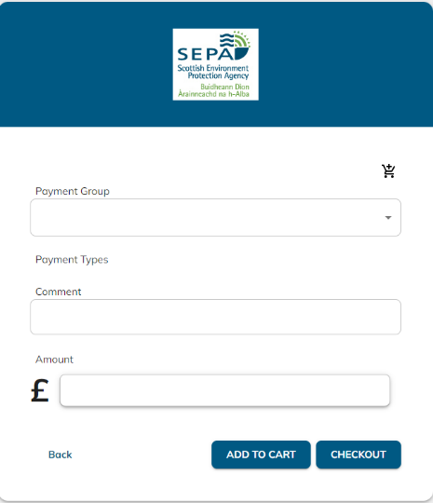
Payment Group: select Application RSA
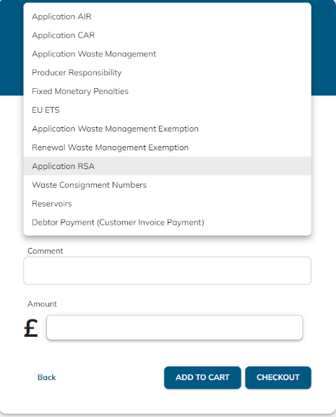

Payment Types:
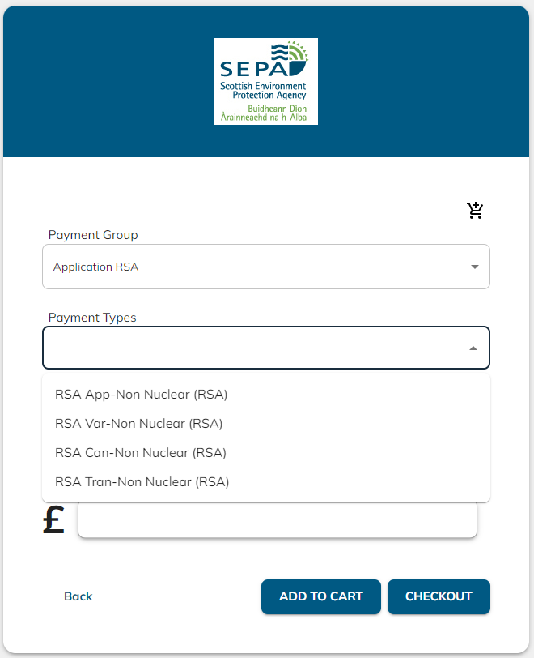
For new applications select RSA App-Non Nuclear (RSA)
For variations select RSA Var-Non Nuclear (RSA)
For surrenders select RSA Can-Non Nuclear (RSA)
For transfers select RSA Trans-Non Nuclear (RSA)

Comment box:
Add in the authorisation reference the application relates to; the site/installation name; and the type of authorisation: for example…
EAS/P/1234567 NDT Ltd - new HASS application
EAS/P/2345678 Glasgow Hospital - non-nuclear variation
EAS/R/3456789 Borehole Ltd - Outwith Scotland registration surrender
EAS/P/1357924 Robin Platform - NORM transfer
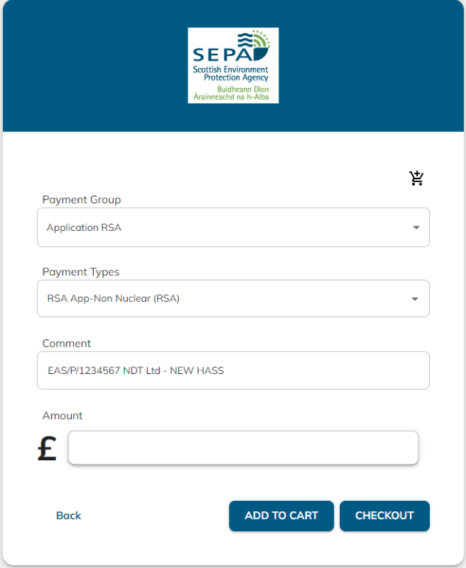

Amount box:
Insert the relevant application fee, as detailed in Appendix A, above.
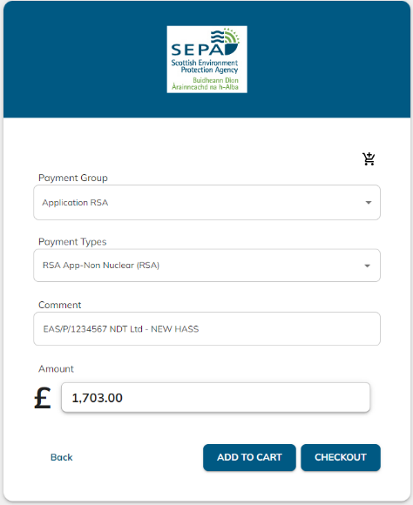
If submitting multiple applications, click “add to cart” and repeat the above process for the other applications, otherwise click “checkout” to make payment.
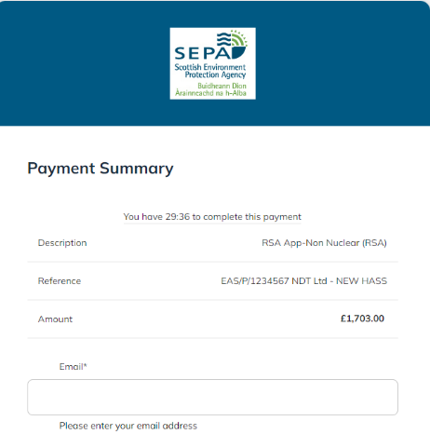
Top half of the screen provides a summary of the application(s) info you have entered – if incorrect click “back” at the bottom of the screen and amend as required.
Enter the email address of the person we can contact in relation to the payment.

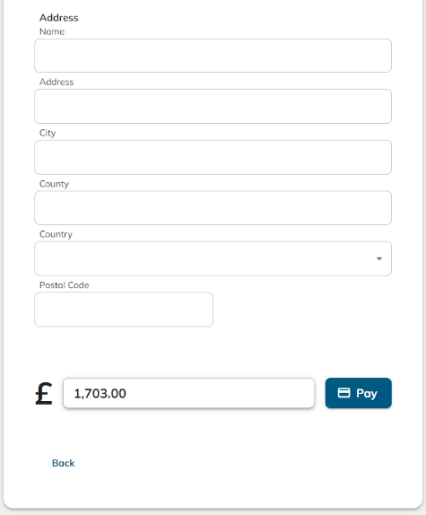
The bottom half of the screen, enter the contact information of the person/company making the application payment and then click “pay” to submit your payment details.

If you would like this document in an accessible format, such as large print, audio recording or braille, please contact SEPA by emailing equalities@sepa.org.uk

